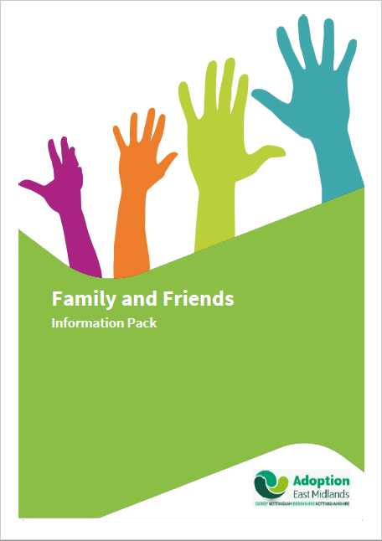

Contents

Chapter | Title | Page No.
 | Introduction | 2
 | What is Adoption? | 3
 | The Adoption Processes (of the child and adult) | 4
 | Why Parenting Adopted Children is Different  to Parenting Birth Children | 5 - 11
 | Supporting Attachments – Article by Adoption UK. | 12 - 15
 | A Guide to Talking to Children About Adoption | 16 - 21
 | How Many Grannies am I Allowed to Have? | 22 - 24
 | “They’ve Adopted Him as Well!” – Article by Adoption UK | 25 - 29
 | Contact in Adoption | 30 - 34
 | Where to go for Support/Advice | 35
introduction

“Nobody can successfully parent in a vacuum!
All families with children need support and back-up”.

When a child joins their new family, friends and family members (who become related to the child by adoption) can all play an invaluable role in helping the newly-established family to bloom.

This course, and accompanying handbook, has therefore been designed to raise-awareness about adoption-today, the adoption process, the children needing adoption, and most importantly, help you understand how adoptive families can help adopted children to recover from their difficult start in life.

We hope that this training will:

- Help you to understand more about modern adoption.

- Provide an opportunity for you to think about how you can support and be involved in building a family through adoption.

- Offer a chance for you to meet with other adoptive grandparents, family and friends, to share any feelings, hopes and fears you might have about adoption.

- Help you to prepare for an adopted child to be placed in your family &/or friendship network.

What is Adoption?

“I grew in my mummy’s heart instead of her tummy” –
(Quote taken from an adoptive child).

Adoption is a way of providing a new family for children who cannot be brought up by their own parents.

It is a legal procedure whereby all legal ties with the first mother and father (the “birth parents”) are ended and the child becomes a full member of the adoptive family.

The Court transfers all legal and parental responsibility for the child to adopters by the making of an Adoption Order, and once an Adoption Order has been granted it cannot be reversed except in extremely rare circumstances.

Why parenting adopted children is different
to parenting birth children?

Suffering trauma such as neglect and abuse in a child’s early years has a profound effect on the development of the brain.

Research has also shown the development of the brain can also be affected in the womb. If children experience neglect and abuse before they are able to talk, these experiences of trauma are held as memories in their brain and can be triggered in the future by similar sights, sounds, smells or touch. When these trauma memories are triggered it can lead a child to become very anxious and/or feeling unsafe.

When children feel threatened their brains are catapulted into a mode of fight, flight or freeze. This may lead the child to become confrontational and be verbally or physically aggressive (fight), run from the situation (flight), or remain quiet, go into a day dream or go to sleep (freeze.)

This is a reactive survival mode not a conscious action, therefore children are not choosing to behave in this way. These behaviours are part of the child’s survival strategies as they have not been able to trust adults in the past.

Suffering trauma in the early years can lead children to be hyper- vigilant i.e. always on the alert for danger or any changes in their environment which may occur. This affects their ability to manage situations as they are often in an anxious state, which in turn can lead them to respond in an outburst of rage in order to keep themselves safe.

Such early life experiences affect the development of the cognitive brain which is often not as well-developed as would be expected for the child’s chronological age. For example, children may need help to organise themselves, remember and process tasks, even day-to-day tasks, and this may continue even as they approach and reach adolescence.

Children can seem to be controlling and manipulative. They are often in a state of constant anxiety – always testing relationships, pushing people away for fear of being rejected. This can be noted through observing a child’s behaviour and can be very evident when a child dysregulates (loses control.)

Adopted children can also be unable to ‘tune in’ to how others may be feeling.

When feeling anxiety or stress or when in fight, flight or freeze mode a child will be unable to think and will find it hard to process and complete even simple daily tasks. This can be very frustrating for the adult.

Adults around the child need to act as a support and help children stabilise their emotional state.

Adopted children may have a lot of feelings we might call ‘toxic waste’ from their early years of neglect and abuse. The child cannot rid itself of these feelings until they truly feel safe and this can take a long time – in the meantime adopters often find themselves acting as the ‘waste bin’ into which all these feelings are deposited. This can be exhausting as it can happen so often and processing these toxic feelings is hard. Accessing support is vital to keep yourself healthy.

Behaviour as language –

- How do we understand what our child’s behaviour is trying to tell us?
- How do we parent our child when we/I don’t understand what they are saying?

Most of us base our parenting on how we were brought up in order to meet the emotional needs of our children and set boundaries for them. This works fine when parenting birth children, but with almost all adopted children the additional task of re-parenting is the challenge. If we are self-aware we are more likely to look for support for ourselves, and this becomes particularly important when we find ourselves feeling negative about our children.
The emotional gaps in our child’s development make it hard for them to function in a world that has not given them the foundation tools. It also may make it hard for us as parents to understand their needs.

- How can we as adoptive parents begin to create an attachment with our children and become attuned to their emotional state?

We have gained wisdom from Dan Hughes, who talks about P.A.C.E.:-

The P is for PLAYFULNESS -

Children cannot feel the pain of shame when they are laughing. Humour helps to regulate strong emotion. Humour shows acceptance.

The A is for ACCEPTANCE –

Our children need to feel their parent accepts their current emotions and stage of development. It is important your child does not feel condemned, criticized or rushed. It’s OK if you are helping them with tasks that you might consider they should be old enough to do for themselves, for example, telling them every day to use the bathroom, helping them clean their teeth or to put their shoes on. It is a chance to re-parent and they can eventually move on. Responding to a furious child by commenting ‘I can see you are really angry’ tells them you accept their right to show that emotion – it is unconditional acceptance.

The C is for CURIOSITY -

A good way to demonstrate this can be by guessing. Instead of being blunt with your child or telling them you know how they feel better than they do, you could try saying, for example, “I wonder if you felt sad because it reminded you of...” This is non- confrontational and not intrusive. It also allows you to make mistakes. In this way we can begin to help our children make connections between how they feel and what they have experienced. Timing is important: sometimes when a child is angry you cannot talk to them and have to wait until they have calmed and are able to hear you.
The E is for EMPATHY -

This allows us to show our children that we validate what they are feeling and that their feelings are important to us. We may not like our children’s feelings but they are real to them. For example when your child arrives home from school and they begin talking about how other children have hurt them or been mean to them, rather than asking what they had done to other children, it would be more helpful to your child to respond by using comments such as ‘It seems like you’ve had a really hard day.’

Parents have found that using the PACE approach opens channels of communication and helps begin to give children the experience of someone hearing what it is like to be them. Once children feel heard, it becomes more possible for them to see themselves through your eyes. This means they are no longer stuck in the traumatized place of silently seeing themselves as bad and offers them an alternative to using a language of unhelpful and sometimes harmful behaviour to try and break the silence that no one understands.

There is no such thing as a quick fix when we are trying to get alongside our children’s pain and confusion. This can often be very hard for parents, especially if you don’t feel heard yourselves, or perhaps don’t have a sense that others care about you. It helps to remember that no-one gets it right all the time and that it is OK to ask for support.

THERAPLAY -

Theraplay is a therapeutic approach, developed in USA in 1960s and practised worldwide since, designed to help children to build their attachment relationships with parents and carers. It has particular value for adoptive and foster families because of this focus. It allows early developmental gaps, created from trauma or neglect, to be filled, by basing its interventions on simple games which encourage touch and eye contact in a safe, non-threatening and fun way.

This playful approach is designed to build relationships. It is simple, fun and non-shaming for the child and it achieves big things in the brain!

Theraplay is a way of helping children grow and develop. It helps children to connect with others and their own emotions as well as giving early developmental experiences which may have been missed. This approach will help undo the “old wiring” and superimpose the better wiring.

Main principles of THERAPLAY:-

The goal is that the child will become more at ease with adults and other children have less of a need to stay in charge and be able to experience and express feelings.

The activities are simple, closely involve parents and FUN!

Theraplay has four dimensions, each one of each has activities to help meet the child’s needs, which are:

- To feel loved…This happens through being touched, soothed and cared for. This make the world feel safe and secure. The message to the child is LET ME TAKE CARE OF YOU. In Theraplay, this known as NURTURING and the activities are especially helpful in building attachment.

- To be heard and involved…This happens through stimulation and variety and teaches the child that surprises can be fun. The message to the child is ‘COME AND JOIN IN’. In Theraplay, this is known as ENGAGEMENT and is especially useful for withdrawn or wary children.

- To live with order…This happens through knowing that the adult is containing and teaches the child to co-operate and accept authority. The world becomes safer and more predictable and gives the message to the child that ‘IT IS OK FOR ADULTS TO TAKE CHARGE’. In Theraplay this is known as STRUCTURE and is especially useful for children who are overactive and who feel they need to be in control.

- To take risks…This happens through taking on new experiences and helps the child feel competent and confident. The message to the child is ‘LET ME ENCOURAGE YOU TO HAVE A GO’ in Theraplay this is known as CHALLENGE and is especially useful for children who are withdrawn or timid.

Helpful Phrases -

These phrases sometimes help the child not to feel judged or told off. It may help them to realise why you are making certain decisions.

- I can see you’re finding this difficult at the moment – I will stay close by – let me know when I can help you.

- I can see that you really want to ‘child’s request’ and I know you will be disappointed but I can’t agree to child’s request at this time.
Validate any ongoing emotional reaction. Look at when / how to make happen in future.

- I can see that’s really hard for you to hear.

- I noticed you _____________________
I wondered if you’re (use words that child will be familiar with)

- What a BIG BIG feeling – that must be so hard for you – lets shout together. (Then bring emotion down together) – regulating emotion.

- I’d rather you didn’t do that (use this phrase rather than saying ‘no’).

- I am hearing what you are saying – but I’m not able to give you the answer you want.

- I’m sorry I’m not getting it right for you – but I feel I’m making the right decision.

Article From Adoption UK:

“Supporting Attachment -
Ways to deal with attachment issues”

Behaviours and how to build trust.

- Everyday activities -

- Start making mealtimes, getting up and going to bed part of a predictable routine.

- Say clear ‘goodbyes’ and ‘hellos’ and talk openly to your child about why you have to go away sometimes and for how long it will be for.

- Use a calendar or a diary chart to help your child predict and anticipate events

- Make sure your child feels specially cared for and nurtured when ill or hurt or sad.

- Be discreetly available if your child is anxious but finds it hard to talk or accept comfort for example suggest a ride in the car.

- Give your child both your spoken and unspoken support to safely explore the world around them

- Building Trust When Apart -

- Let your child take a small item or photo from home to school.

- Phone or text your child to let them know you are thinking of them.

- Show you have thought about your child during the day by placing a small surprise on their bed when they are at school.

- Games and Activities that help to build trust –

- Reading stories with your child sitting on your lap or close to you.

- Face painting

- Throwing a ball or bean bag to each other

- Rocking, singing gently holding your child.

- Brushing and plaiting hair

- Teaching a new skill or learning one together.

- Helping your child to manage their feelings and behaviours –

- Anticipate what will cause confusion and distress in your child and avoid if possible

- Express interest at a level that is comfortable for your child in their thoughts and feelings

- Help your child to make things better after losing control of her feelings and praise them for doing this

- Use stories or puppets to develop empathy in your child (e.g. “poor baby owl, how does he feel now his mummy has flown away to get food?”

- Observe your child carefully—perhaps keep a diary note patterns etc and try to stand in your child’s shoes.

- Collect tickets pictures leaflets stickers etc and make an ‘experience book’ to help a child remember and reflect on positive events

- Use play, television programmes and real examples to make sense of the world and how thing work cause and effect.

- Promoting Attachment –

There are many things you can do to reparent your child and help them form a secure attachment with you their new carer.

- Use your child’s tantrums to encourage attachment

- Help your child express and cope with feelings of anger and frustration, feelings about moving or ambivalent feelings about their birth family.

- Respond to your child when they are ill hurt or injured.

- Make affectionate overtures: hugs kisses and physical closeness.

- Teach your child about extended family members through pictures and talk, and to participate in family activities such as camping or outings.

- Teach your child to cook or bake.

- Say “I love you”

- Encourage your child to call you Mum and /or Dad

- Hang pictures of your child on the wall

- Involve your child in extended family visits or reunions.

- Make statements such as “in our family we do it this way” in a supportive manner

- Include the child in family rituals.

Taken from Preparing to Adopt: The applicants’ workbook. (BAAF)
Originally published by Be My Parent.

A Guide to Talking About Adoption

Explaining the circumstances of adoption is not a simple task. It involves acknowledging that your child is adopted, without making too much or too little of it.
It is important to impart difficult facts about their background and their earlier life in as constructive a way as possible.

For parents and children alike, it involves facing strong emotions.

Some parents hope that if only they can explain things “properly”, then their children can be spared some of the upset of trying to make sense of adoption.

A renowned psychologist, David Brodzinsky, has explored children’s understanding of adoption at various stages of their development, and offers these basic guidelines to sharing information about birth families with children of different ages. These suggestions are a guide, as children vary in their speed of emotional and intellectual development, and their ability to understand.

Key Points –

- There is no absolutely “right time” or “right way” to talk about adoption.

- There are simply opportunities to share some of the facts at different stages of your child’s understanding throughout childhood.

- Explaining and exploring adoption is a continual process. Information takes on new meanings as children grow up, and they need to hear the same basic story developed and amplified over the years.

- A child’s silence about adoption does not automatically mean lack of interest. Appearing indifferent, or bored, may mean a child is struggling to make sense of what she/he has been told and only she/he knows how much she/he can take in at any one time.

- The child may also have picked up and is reflecting some of your anxiety in discussing the subject.

- You cannot make any sad or distressing information about family background easy to hear – but you can only make it easier for your child.

- Distinguish between birth parents’ actions and their overall value as people. The more comfortable you feel with background information, the more confidently you can pass it on to your child. Some parents rehearse the details of the child’s ‘story’ a long time before the child may wish to know.

- Always be honest, even if the facts are difficult. Choose words that explain the situation but leave room for details to be added as your child grows older. For example: “your birth mother didn’t really know how to look after you, and sometimes she hurt you”.

How Children Understand Adoption –

- Babies and Children 0-4 years of age -

Very young children have no understanding of adoption. However, if parents talk about it from the start e.g. through a favourite bedtime story, they will become more confident about the subject. They will pick up the positive value their parents place on the word long before they know what adoption means. This creates a comfortable and open atmosphere around the subject.

Children placed trans-racially become aware of racial differences and social values placed on skin colour before they can talk. They are sensitive to people’s reactions to them long before words have any meaning.

3-4 year olds do not understand the difference between birth and adoption, although some express sadness they didn’t “come out of your tummy”. That is something good that they would have liked to have happened because it means being close to you.
Keep your story brief; simple and accurate e.g. “you came to live with us because your birth mummy couldn’t look after a baby”.

- Children 4-6 years -

Children of this age have started to understand about the birth process and are usually interested in babies’ genitals! They ask “why” repeatedly, but still do not understand the difference between birth and adoption, i.e. some may believe everyone is adopted. They can mislead you with apparent “understanding” by repeating thing you have said.
School introduces children to other people’s reactions. By 6 years of age, children know to which racial group they belong, and that in society some people are valued more than others.

Children of this age are not particularly concerned about adoption, but they play out a lot of family games and use “magical thinking”.

Keep the adoption story simple. Be specific, e.g. “we collected you from your foster home in the car, when you were 2 years old”.

- Children 6-8 years old -

Between around 6 and 8 years of age, children begin to differentiate between birth and adoption as ways of entering a family. They accept adoption as a permanent state without understanding why. They accept things “because mummy and daddy said so.”
They begin to wonder why their birth family “could not keep them” and can accept your concentrated explanations e.g. “They were not well enough to look after you at that time”.

- Children 8-10 years of age -

This is a time for gathering information and solving problems!

Children understand by now the difference between birth and adoption, and they may begin to doubt the permanence of all relationships.

It can be a disturbing time for adopted children, as they realise that social situations change. These are some questions that this child may think or ask: -

“If my mother was unable to look after me before, could she now?”

“If she could not look after a baby, can she look after me now I am older?”

This could lead to thoughts of “will she come back to get me”?

8-10 year olds need to be reassured. You may explain that “your birth mother may be better now, but you are going to stay part of our family forever.”

It is also important to explain that the birth family probably couldn’t have cared for any child, not just him or her.

Children sometimes become withdrawn, depressed or angry at school or home. They realize that to have gained their adoptive family they had to lose their birth family, and they need to mourn these losses.

This stage of development is ‘adaptive grieving’. It involves anger, denial and despair about the past. Some children do no talk about adoption when they are sad; others find it helpful to have their sadness recognized.

- Children 10-12 years of age -

Understanding of the social problems which lead to adoption becomes more sophisticated (e.g. possible lack of support for their birth family, or infertility for the adopter).

Children are more confident that things will stay as they are, i.e. they will remain in their adopter’s family, and have some idea of the role of social workers and the court.
They become more secure at home and school. They can discuss why their parents decided to adopt, and understand that children need different sorts of care, above the basic needs of enough food and somewhere to live.

- Children 13 years of age and above -

Identity is so important for any children of this age. They ask, “Who am I?” Teenagers need facts. It is worth writing to the placement agency to see if there is any updated information on the birth mother and other relatives, which will help at this stage, in addition to the life story book.

Without facts teenagers may fantasise or idealize their birth family.

Many ask for photographs and obsessed with what they look like and who they resemble. They need as real a picture of their first family as they can obtain. They may idealise or ‘rubbish’ these details, in the same way they may accept or criticise you.
Some children try to assume their birth parents identities (their hobbies, interests, talents) and appear to reject everything you represent.

It is an age of confusion and turmoil for most adolescents and adopted youngsters can struggle to make sense of having two families. Many grieve the loss of their first “identity” and empathise with the distress of their birth families as they become more aware of the complexity and sadness involved in a family breakdown.

The loss of racial/cultural identity for some trans racially placed children of this age group is acute.

Some of the reasons for adoption (including incest/rape) will always be hard to share. The “right” time will depend on the young person’s maturity and your own ability and level of comfort in talking about facts openly.

Be clear about the facts, offer support in seeking more information, be prepared to talk about the adoption and allow the young people to mourn their losses. Whilst all this is happening hold onto your belief in yourselves as parents.

A useful publication on this subject is: -
‘Making Sense of Adoption, A parents’ Guide.’ By Lois Ruskai Melina. Published by Harper and Row

ARTICLE FROM ADOPTION UK

“How many grannies am I allowed to have?
When a child enters a new family, as well as their new Mother, their new father, their new siblings, they have to take on board a whole, sometimes complex, network of new relatives…”

Heidi Argent explores how grandparents and other relatives can play a role in making the newcomer feel part of the family, in BAAF book “Related by Adoption”. Bearing in mind that “Every family tells a story,” Hedi asks: “How will a child enter the family circle and catch up with the stories?”

New parents may be too busy with the many aspects of the parenting-by-adoption task to fill the child in with what other children learn from the cradle. They might welcome an offer of help from grandparents or other relatives.

And this is exactly what the grandparent of an adopted ten-year-old white girl did.

“I fetched her from school on Thursdays and she came to my place. We made a ritual out of it. First there was milk and a different cake I made for her every week. She liked to know about baking, so we wrote the recipes out together and pasted them into a folder that she kept in my kitchen with my cookery books.

Then it was the family albums. She always remembered where we’d left off the last time but more often than not she wanted to go back a bit or start again from the beginning. Sometimes she asked that many questions, it set me off on memory lane, so we only had time to look at a couple of pages before it was time to take her home.”

However, “there is yet more to accomplish for the child entering the new family circle,” Hedi reminds us. “Every family has its own lifestyle, its own system, as well as its own stories.”

A prospective adopter of a white six-year-old girl vividly describes how confusing this can be: “Tracy had mostly chips in paper bags with her birth mum. Her foster carer was very strict about eating at regular times, sitting up at the table with the other children. Now she can’t figure out how to handle our more casual style of eating together, on our laps, at different times to suit the working members of the family. She goes frantic if a meal is late; she always wants to know what the rules are, even when there aren’t any.”

Dana, a black girl of 11, says about her new, black adoptive family: “They’re not too bad but they speak posh, they don’t watch Big Brother, they don’t know nothing about football and we’re always having to go to the library. Then they made me save half my pocket money. I don’t know why. But I like then ‘cause they’re nice. And there’s all the aunts and uncles and grandma and that – they’re all like that – but they’re nice too.”

These two girls have a past, which is very much part of them and their outlook on life. Hedi is reassuring when she points out that: “We sometimes talk about going back to our roots; plants have roots, people have legs and can move. Children can move to new families without lasting damage but the transition has to be managed without breaking the thread of continuity with the past and the connection to their birth family.”

Here again, relatives can play a crucial role, in this case the grandparent of three adopted siblings: “When it was time for one of those contact meetings, we always made a family occasion of it. We’d plan a picnic or some kind of outing and it would be the children and my daughter and son-in-law and me; Beryl (birth mother) would bring her mother along and that made it easier for the children; it opened it out more somehow and they could see that we all got on together. Their granny was a nice woman but very shy. The children really liked seeing her but I don’t think she’d have come if I hadn’t been there. The younger one said to us at one contact meeting, How many grannies am I allowed to have?”

Of course, not all grandparents and relatives find it easy to accept the new child, as one grandparent of an adopted teenager explains: “I couldn’t see how they would let my (gay) son adopt. I was worried about the boy turning out gay and social services blaming my son. I was sort of ashamed about being his grandmother and I made him call me by my first name. This went on for a long time, it must have been five years, till the boy himself said to me: “I haven’t got a mother but I’d like for you to be my grandmother.” I realised then that I’d been his grandmother in all but name and that he and my son were more clever about it than I was.”

The quotes above give a flavour of this thought-provoking, helpful BAAF booklet “Related by adoption” (2004). It includes sensitive, information answers to questions such as:
- Can I be a real grandparent to unrelated children – will I be able to love them?
- Will an older child learn to love their new family?
- What are the obstacles some adopted children face?
- How will the child fit in with existing grandchildren, nephews and nieces?
- What is meant by behaviour problems?
- How will we cope with a disabled child?
- What help is available?
- What happens if an adoption doesn’t work out?
- What do I want to do? What do I think I should do? What can I do?

Finally, Joyce and Eric Stanway (grandparents to the extended Cairns family), remember:

“We were also a way for the child to understand more about the family they had joined. We watched them watching us and trying to learn how this family ticked… For these older children, whose own parents were not available, grandparents could be an unthreatening way to finding love and care.”

Written by Leonie Sturge-Moore.
Originally published in the Be My Parent newspaper in March 2004.
ARTICLE FROM ADOPTION UK

“They’ve adopted him as well!”

Penny was a single carer who had just been assessed to adopt. Her family and friends made up a support network that didn’t have a clue about adoption! So why does Penny now say that she couldn’t have done it without them?

“Most people assumed I was going to adopt a baby from abroad,” begins Penny, with a sigh. “Their views on adoption were about 20 years out of date! I did tell friends and family that there are lots of older children in this country who need adopting and have maybe been in the care system for two or three years. They found that really shocking. But they still couldn’t understand why I would want to adopt a child of school age!”

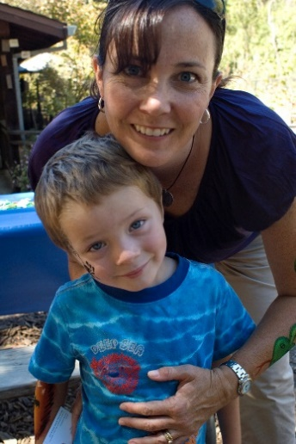
Penny’s friends and family were soon to discover the reality of adoption – much sooner than anyone expected. Shortly after being approved, Penny looked through the April issue of Be My Parent, which she had just subscribed to. Within a few moments, she stopped turning the pages. “This little five-year-old boy – Nathan – leapt out at me. I was very drawn to him.” Penny met Nathan’s social worker the following month, was approved at matching panel in the summer, and Nathan moved in and became part of her life forever in September 2008.

Penny feels that her support network more than rose to the occasion. “I couldn’t have done it without any of them,” she says. “Some have been ‘all-rounders’, while I’ve put others into categories: for instance, the person who is brilliant with practical support but brushes emotional things under the carpet. But every single person has played a part in helping me.”

Penny hadn’t realised quite how much people would help her – or how much she would need them. When she made the life-changing decision to adopt as a single carer, her social worker made it clear that she would need strong support networks. But Penny assumed she was exaggerating!

“I knew people who were single carers of birth children, so I thought I understood how much work it would be. But after adopting Nathan, I realised that my situation was different. Without a shadow of a doubt, you need greater support as a single adopter, as there are fewer reprieves without a partner. I really had to ask myself, “Who will I rely on?”

When I asked to name the people she has relied on most, Penny doesn’t hesitate: it’s her parents and best friend, Helen. And she says the biggest gift that they have given her is time…

“I return to work in a couple of weeks – the biggest disruption of routine that Nathan has experienced since joining me. And my mum has offered to book two weeks off work to come and help me.”

“But my parents live two hours away, while Helen is here, in the same city, so her help is invaluable. I recently had tonsillitis, and Helen did the ironing for me. She also comes round for a couple of hours every Tuesday to allow me to get on with other things.”

Of course, Nathan has also needed time – time to settle and meet the important people in Penny’s life. To help prepare him before he arrived, Nathan received a ‘Book of Me’, full of pictures and information about his new family. Penny placed a framed picture of her parents in Nathan’s bedroom. She used the same washing powder as his foster carers so he would be familiar with the smell in his clothes, and bought all his favourite foods. “We did all those things that you’re supposed to do to ease and settle a child in. But it was always going to be a huge move. He was changing a whole family. He had never ever been to this city before.”

Penny says that even the people very close to her can sometimes struggle to understand Nathan’s difficult early experiences.

“My mum’s tried really hard to take it all in and now knows about attachment difficulties and things like that. But it distresses my dad to think that anything horrible happened to Nathan in the past, so he just sweeps those things under the carpet.”

Penny’s voice grows quieter. “They still manage to support me emotionally. Nathan has therapy every week with the Child and Adolescent Mental Health services (CAMHS), which really affects us both. I wouldn’t talk about that kind of thing to everyone – but I know that I can drip-feed details to Helen and my parents, on a need-to-know basis, and they will be there for us.”

It sounds like Penny’s support network is now very much Nathan’s too! “He’s slotted into our family so quickly. He desperately wanted a new mummy and family, so he absolutely loves being here. It also helps that Nathan is a gregarious boy who is very easy to love.”

Penny knows that there are likely to be tough times ahead. She knows that she will continue to rely very much on the people around her for support. But Penny doesn’t think that prospective single carers should be put off by this. Nor should they worry that their support network may not be big enough to adopt. Penny is keen to point out that it is usually a small group of people who prove themselves the most, and the ‘little things’ that make the biggest difference…

“It’s been a journey,” laughs Penny, with understatement. “It’s been a journey for Nathan and me, for all of us – we’re on this journey together and we are certainly closer because of it. I now know that you don’t adopt on your own – your support network adopts as well.”

The Best Friend…Helen
“My job is to be somebody who notices.”

Penny and I are more like sisters than friends. We met in the mid-90’s when we did teacher training, and since then, we’ve shared a house together, travelled together, and now gone through adoption together…

I actually thought about adopting first. Then we both split up with our partners around the same time, and Penny decided to go to a meeting about adoption. I went too, but as her support. Just before Penny went to panel, I decided to go down the adoption route – so although I’m a year behind, I can understand the process.

Since Penny has adopted, I’ve welcomed the opportunity to lend her support. She’s very self-sufficient and I probably leant more on her in the past. Unless you are close to Penny, you might not even realise that she needs any help. So my job is to be somebody who notices.

I don’t think my relationship with Penny has changed since Nathan joined her, but I’m very aware of the implications of me adopting as well, especially how I will maintain my support. I also have to think about how it will affect my relationship with Nathan, who sees me as a piece of the furniture – in the nicest possible way!

Being a big part of Penny’s support network has been an eye opener. I’ve always known Penny was wonderful, but I couldn’t possibly have imagined that she would be such a wonderful parent. Being a part of her life since she has adopted has allowed me to see her in a totally different light: I’ve seen a more patient, vulnerable side. And I’m just filled with admiration.

The Grandmother…. Sharon
“It’s important that Penny doesn’t feel on her own.”

“From the very beginning, we knew adopting would be hard for Penny because she is a single mum and older children have gone through a lot of trauma. We knew all this because Penny kept us so well informed. She gave us books to read and reported back information from workshops. We were painted the blackest picture possible – and, actually, the reality has been incredibly positive, with no problem insurmountable!
We try to see Penny and Nathan about once a fortnight, as it’s important that Penny doesn’t feel on her own. She’s a new mum, and has been bombarded with cooking and cleaning, as well as the childcare, so I mostly help with mundane chores! I like to give Penny time to focus on Nathan and spend time with him.

Her dad and I are also here as support for Nathan, to provide further stability, as he’s had so many changes in his life. We hope he understands that we’re part of his ‘forever family’ – that won’t have to leave us. Last time he came over, he made some people with Playdough. He said: “That’s my family: me, mummy, grandma and grandpa.” It brought a lump to my throat. And if anything exciting happens, like he gets a certificate from school, he phones us up to tell us. We love him to bits.”

Contact:

‘Contact’ is the term used in adoption referring to the ways that children retain links with birth family members.

There are two types of contact:

- Direct contact: this is face-to face meetings which is usually recommended only for siblings who also are in adoptive homes. It supports the children to maintain an ongoing relationship. This is usually annually (or sometimes more). It can reduce the losses that children face through their adoption journey and also highlights the importance of a sibling relationship. And it allows adopters to share information about the children they are caring for.

- Indirect contact: this is usually in the form of ‘letterbox’. It is the usual recommended contact for adopters and birth parents and/or wider family members. The Letterbox scheme is a confidential service which allows information to be exchanged between birth relatives and adoptive families. The service is run by the Adoption Support Service.

Why have a Letterbox Scheme?

It helps the adoptive child:-
- keep in touch with birth relatives
- know more about their origins and background
- be aware of changes in the birth family should they wish to make contact as an adult

It helps the birth relative:-
- learn about the child’s progress and interests
- tell the child about what is happening in the birth family
- be aware of the changes in the child’s life

It helps an adoptive parent:-
- answer the child’s questions
- learn important news about the child’s birth family e.g. Medical information and the birth of brothers or sisters
- maintain links with the birth family

Who uses the Letterbox scheme?

A Letterbox contact plan is made between the adults although the exchange usually works best when the child is actively involved in some way. Most adopted children will have a Letterbox arrangement but only if it is in the child’s interests and all the people involved agree.

It is usually the birth parents or grandparents who are involved but it can be aunts, uncles, brother, sisters or other important adults such as former carers, as well as, of course, adoptive parents. Careful thought is given to the timing of the exchange and we would normally avoid Christmas, Birthdays and other significant dates for the child.

If either party wishes to withdraw from a letterbox arrangement, we would ask that they provide their reasons in writing.

How does the Letterbox scheme work?

Letters are sent to participants to remind them when a letter is due.

An adoption support worker reads everything that has been sent to make sure that it is appropriate to send on.

Copies are taken and placed on the child’s file. Adoptive parents are informed that a child has the right to see the contents of their files once they reach the age of 18.

Before letters are forwarded to the intended person that person is asked to confirm their address. Once this is done, the letter is forwarded to them by recorded delivery.

We will make every effort to protect the confidentiality of those involved in the Letterbox scheme.

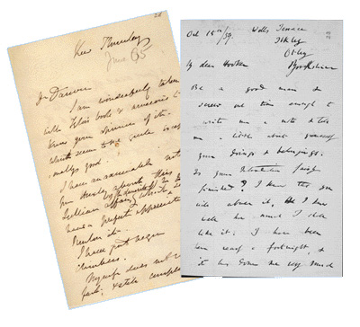
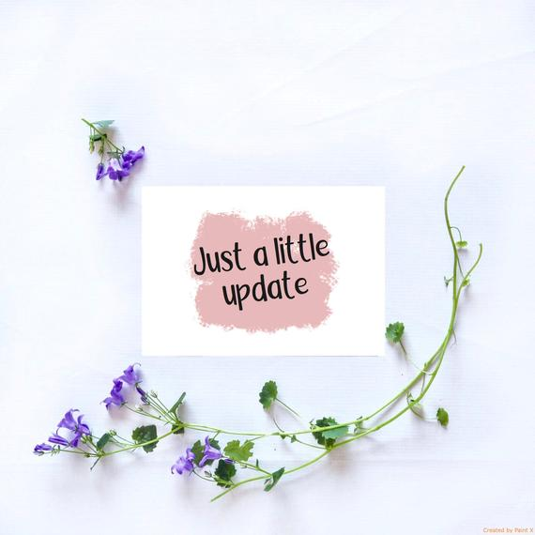
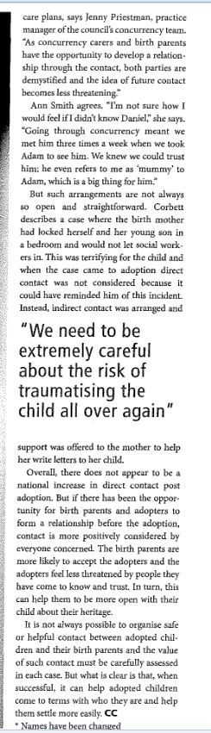


Where to go for support/advice

Adoption UK - Adoption UK was established in 1971 and is the only national self-help group run by and for adoptive parents and foster carers, offering support before, during and after adoption.

Helpline number: 07904 793 974 and 07539 733079 (Monday-Thursday 10am to 2.30pm and Fridays (excluding bank holidays) 10-12pm). Calls will be charged at standard network rates. www.adoptionuk.org.uk

The Post Adoption Centre -
The Centre was founded in 1986 to meet the needs of adults and children experiencing problems arising from adoption. They provide independent advice, counselling and support to anyone affected by or dealing with the challenges and opportunities of adoption.

Advice line: (London) 020 7284 5879 (Mon, Tues and Fri 10am-4pm and Weds and Thurs 2-7pm). (Leeds) 0113 230 2100 (Mon, Tues, Thurs, Fri – 10am-1pm and Weds 4-7pm) www.pac-uk.org

First 4 Adoption - The National Adoption information service for England - www.first4adoption.org.uk

Coram BAAF - CoramBAAF Adoption & Fostering Academy is the leading membership organisation dedicated to improving outcomes for children and young people in care by supporting the agencies and professionals who work with them.
https://corambaaf.org.uk

Grandparents Plus - A national organisation that offers support and training for grandparents and other relatives – www.grandparentsplus.org.uk

Useful Resources -

‘Related by Adoption’ book by Hedi Argent, CoramBaaf, 2014 - This is a handbook for grandparents and other relatives involved in building a family through adoption

‘In On It’, book by Elizabeth O’Toole – offers practical advice for how relatives and friends can best help and support an adoptive family.



